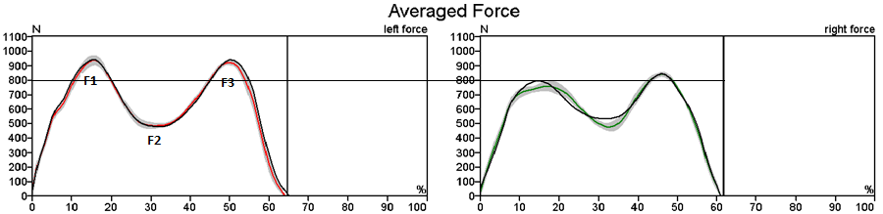

**F1** occurs at the onset of mid stance in response to the weight-accepting events during loading response. At this time the body‘s centre of gravity is rapidly dropping, an action that adds the effect of acceleration to body weight.

**F2** is created by the rise of the centre of gravity as the body rolls forward over the stationary foot. This valley is accentuated by the momentum of the swinging, contralateral limb, which tends to unload the force plate.

**F3** is occurring in late terminal stance, again indicating downward acceleration and lowering of the centre of gravity as body weight falls forward over the forefoot rocker in terminal stance. Hence, the vertical force above the weight line represents the acceleration of dropping onto the limb initially and then falling beyond the forefoot in terminal stance.

**F = M ( g + a )**

Since M and g are constants, the force on the force plate changes with changing vertical acceleration.

a = 0 🡪 the force is body weight

a < 0 🡪the force drops below body weight

a > 0 🡪 the force goes up

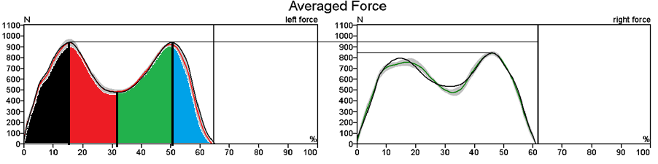

**Loading response**

* *Restrained knee flexion:* Shock absorption is provided by the quadriceps limiting the arc of knee flexion. This muscular action also maintains weightbearing stability at the knee.
* *Restrained ankle plantar flexion:*The heel rocker continues body progression, while also contributing to shock absorption.
* *Hip stabilisation:*an erect posture of the trunk is preserved.

 **Mid stance**

* -ky in the same position for too long. He cannot do that on the Ceterus.ake small movements in order to ut of it . *Restrained ankle dorsiflexion:* The ankle rocker motion allows forward progression. Triceps surae muscle action to restrain the rate of tibial advancement is a major determinant of knee stability.
* KneeKn*Knee extension:* Progressive straightening of the knee increases weightbearing stability of the limb.
* *Hip stabilisation in the coronal plane:* Abductor muscle action stabilises the pelvis in a level posture. This provides an appropriate base for an upright alignment of the trunk.

**Terminal stance**

* *Heel rise:* The forefoot rocker allows body weight to advance beyond the area of support. Dynamice stabilisation of the ankle is an essential element of the heel rise.
* *Free forward fall of the body:*This is the major component of progression. It also creates instability in sagittal plane balance.

**Pre-Swing**

* *Knee flexion:* Most of the knee flexion range used in initial swing is attained during this final phase of stance. The energy for knee flexion is the release of potential energy through indirect reactions from actions at the hip and ankle.



The vertical force shows a characteristic double hump, which results from an upward acceleration of the center of gravity during early stance, a reduction in downward force as the body ‘flies’ over the leg in mid-stance and a second peak due to deceleration, as the downward motion is checked in late stance.

According to the article Giakas & Baltzopoulos (1997) the mean and standard deviation of the three peaks should be:

|  |  |
| --- | --- |
| F1 | 117+/-9%BW |
| F2 | 75 +/- 6% BW |
| F3 | 109 +/- 5% BW |