Black: Ground  
Red: +5V  
Green: CH A+ (Analog, PWM)  
Purple: CH B+ (Analog, PWM)

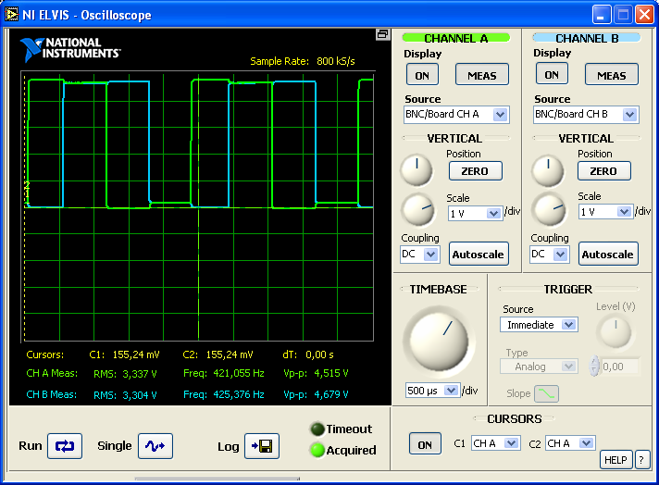

Counter-Clockwise: Channel A is leading Channel B

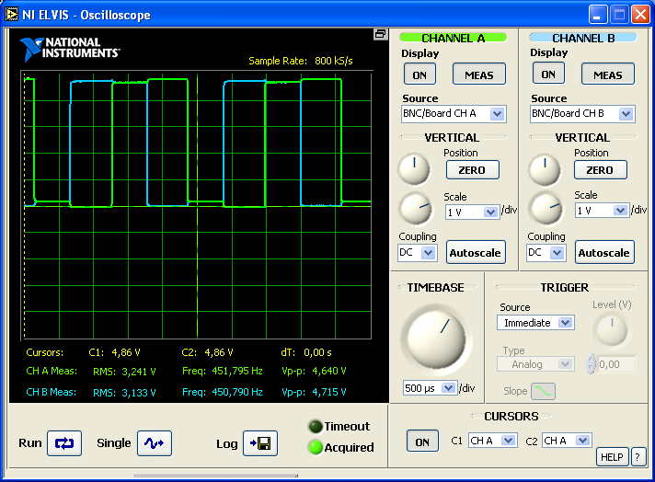

Clockwise: Channel B is leading Channel A